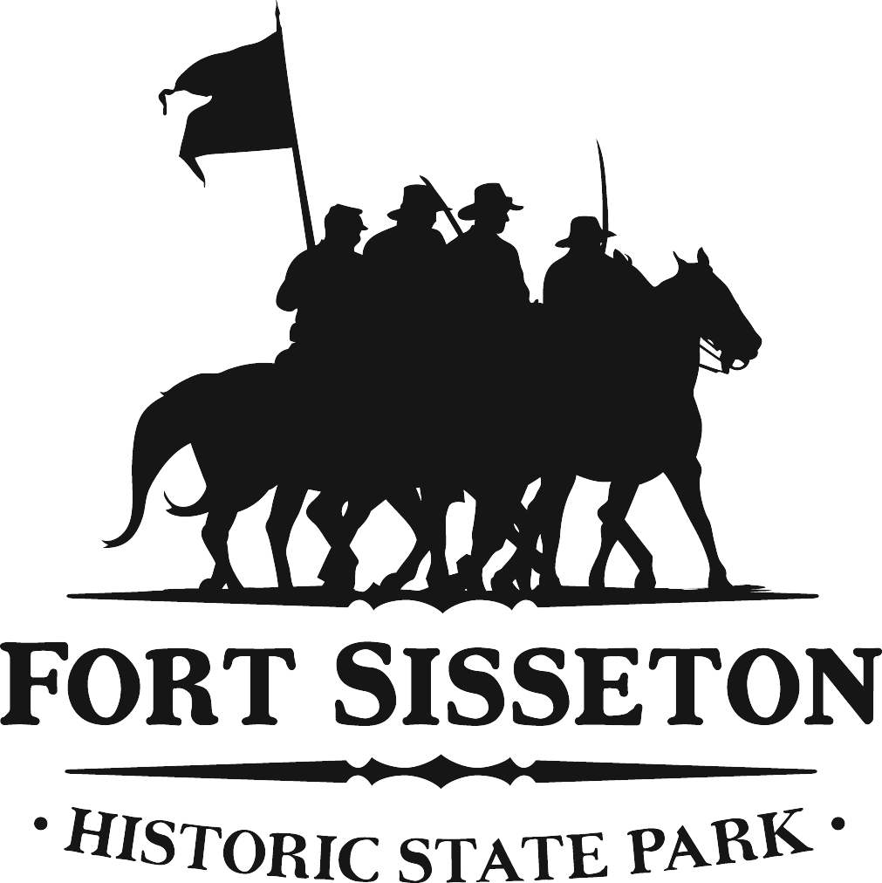

DEPARTMENT OF GAME, FISH AND PARKS
Division of Parks and Recreation

Fort Sisseton State Park
11907 434th Ave.
Lake City, SD 57247
605-448-5474

Dear Food Vendor:

Thank you for your interest in participating in the 2021Historical Festival. As many of you are aware, risk management has become a major part of our operation in recent years, especially as it applies to special events. This year, as last year, all food vendors will be required to carry Commercial General Liability Insurance, Business Automobile Liability, and Worker’s Compensation Insurance as applicable.

Please review carefully the attached materials to see how this may affect you.

To make application for a Food Booth space at this year’s Festival, please review the enclosed Food Vendor Application Requirements, complete the application form, and return it to my office by March 14, 2021. We will select and notify all successful food vendors by April 1.

Again, all application documents will be due by March 14, 2021. These documents include:
- A completed application form
- Certificates of insurance
- Booth payment

Please be aware that the State of South Dakota requires all vendors to comply with SD Department of Health and SD Department of Revenue and Regulation rules. It is your responsibility to make sure you are in compliance with both of these departments. For more information about the SD Department of Health Food Vendor requirements please go to www.doh.sd.gov or call 605-773-4945.

Please follow all CDC COVID Guidelines and Recommendations for Food Services. It is recommended that if you are serving condiments that they are either individually wrapped or put on by the server. This will allow for least amount of contact by the public. One time use silverware is required for use by the public. Hand Sanitizer will be available throughout the grounds but will not be provided to everyone. Please provide the proper cleaning supplies, masks and hand sanitizer that is needed for you, your staff and your booth.

If you have any questions, please do not hesitate to contact the Fort at (605) 448-5474 and ask for
Ali or Dalaine or email FortSisseton@state.sd.us.

Sincerely,

Dalaine Pleinis
District 1 Park Secretary, Fort Sisseton State Park

Enc.

