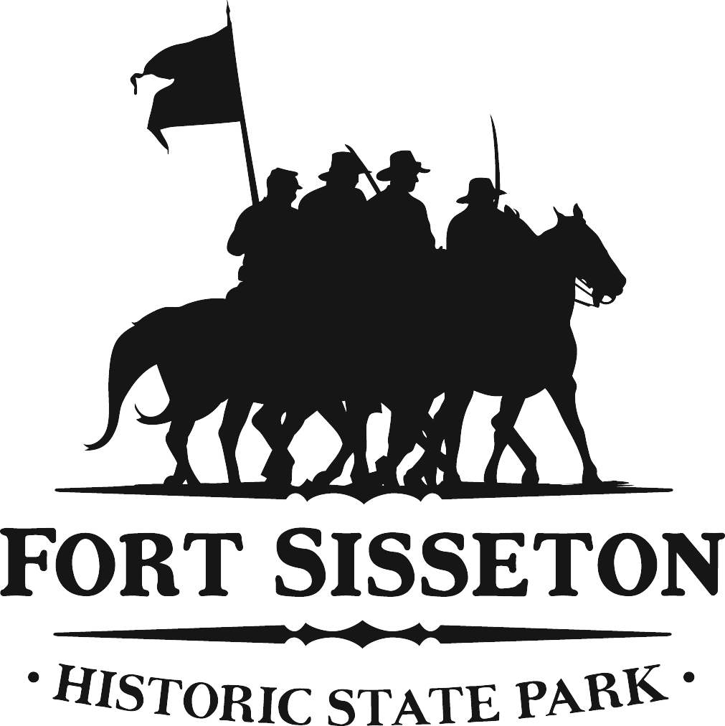

DEPARTMENT OF GAME, FISH AND PARKS
Division of Parks and Recreation

Fort Sisseton State Park
11907 434th Ave.
Lake City, SD 57247
605-448-5474

Dear Arts & Craft Show Applicant,

Thank you for your interest in participating in the Arts and Craft show at the Fort Sisseton Historical Festival. The 2021Festival will take place June 5, & 6, 2021. To apply for a booth space, review the enclosed Art & Craft Show Application/Requirements and complete the application form. Please sign the application form and return it prior to March 14, 2021 We will select and notify all successful applicants by April 1.

Items to note:
- All booth space is located outdoors.
- To set up, vendors will need to enter the Fort grounds through the North Entrance.
- To participate in the Arts & Craft Show, the State of South Dakota requires you to provide proof of automobile insurance. The State of South Dakota requires that you have automobile insurance with liability coverage of no less than $300,000 and property damage coverage of no less than $50,000.
- We must have a certificate of insurance indicating the required amounts of insurance.
- We suggest that you check with your insurance agent to verify that your current automobile insurance policy covers your business activities at the festival. Your agent will best be able to determine if this is the case.
- Hand Sanitizer will be available throughout the grounds but will not be provided to everyone. Please provide the proper cleaning supplies, masks and hand sanitizer that is needed for you and your staff.
- If serving samples or food, please follow all CDC COVID Guidelines and Recommendations for Food Services. It is recommended that if you are serving samples that they are either individually wrapped or handed out by a gloved and masked server. This will allow for least amount of contact by the public.

To confirm your booth space Festival Management must have ALL application documents in hand by March 14. These documents are:
- A completed application form
- Certificate of insurance
- Booth payment
If you have any questions, please do not hesitate to contact the Fort at (605) 448-5474 and ask for
Ali or Dalaine or email FortSisseton@state.sd.us.

Sincerely,

Dalaine Pleinis
District One Secretary, Fort Sisseton State Park

Enc.

